Title of the paper

First name and SURNAME of the authors

Abstract
Please insert a short abstract (summary) here. When writing an abstract, please be aware, it should be informative and stress main conclusions and results of the paper in the very clear and concise form to provide significance of the paper. Use short and direct sentences. The length of the paper should be 10 lines at maximum.

Key words
Please write down from 3 to 5 key words or key phrases separated by semi comas.

Introduction
This paper template provides guideline for authors to prepare a conference proceedings paper in suitable format. Please follow the instruction of this guideline to avoid future complications.
For submission of the paper please name the file with the surname of the first author (e.g. marinic.docx) and upload this file via web page of the conference.
The length of the paper should be at least 4 pages. Maximum pages of the paper are not set, however please have in mind, that paper is a scholar text referring orderly, simply, concisely a consistently about the chosen topic.
Heading for block of text
The layout of the page: Use standard layout with the 3cm edges (top, bottom, left and right). Use Times New Roman font and simple line spacing in whole document. Do not numbering the pages.
The layout of the paper heading: Use bold style font volume 14. Do not divide the words. Use alignment to centre.
The layout of the information about authors: Name of the author(s) is inserted without the degrees in font volume 12. For surname(s) capitals should be used. In case of more authors, full names are divided by semi commas. The name of the corresponding author should be inserted at the first place.
The layout of the abstract: Use font volume 12 with block alignment without any indentation. Use bold style for the heading “Abstract”. Use italics for the text of the abstract.
The layout of the key words: Use italics font volume 12 with left alignment without any indentation. Use bold style for the heading “Key words”. Insert from 3 to 5 key words or key phrases separated by semi commas which capture the essence of the paper. Use italics.
The layout of the text: Use font volume 12 for text with block alignment. For the first line of the paragraph use 0.5 cm indentation. Do not use indentation for the first line after the heading of text´s blocks or in the case of text continuing after the graphics inserted in the text. For headings of text´s blocks use font volume 12 in bold style and left alignment with the spacing before the heading in volume 18 and after the heading spacing in volume 12 - set through the paragraph settings.
The layout of the graphics: If you use graphics in the text of the paper – charts, graphs, schemas or pictures – insert the graphics directly to the text of the paper. Please ensure yourself that the graphics used are readable, sharp and have explanatory power. Number and the name of the graphics insert above the inserted graphics – use bold style of the font volume 12 with left alignment without any indentation. For the source of the creation of graphics insert under the graphics and use italics volume 12 with left alignment without any indentation. (Note: It is recommended prepare graphics in separate suitable program and if possible insert graphics to the text of the paper in the form of picture in case of inserting the graphics to the text of the paper. This procedure should prevent possible deformations during following processing of the submitted paper which could cause uncertainties and non-readability of the graphics.
Graph 1: Example for the graph
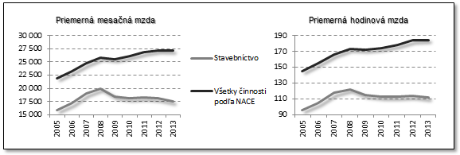
Source: Eurostat, own processing

Table 1: Example for the table
Typ ukazovatele | Výskyt použitia | Typ výkonnosti
ukazovatele založené na tržbách | 52 % | Finančná výkonnosť
rentabilita aktív (ROA) | 29 %
ziskovosť (iná než ROA) | 26 %
tržní podiel | 44 % | Prevádzková výkonnosť
produktivita | 20 %
subjektívne vnímaná celková výkonnosť | 47 % | Celková výkonnosť
výkonnosť v porovnaní s konkurenciou | 20 %

Source: Hult, own processing

Scheme 1: Example for the scheme
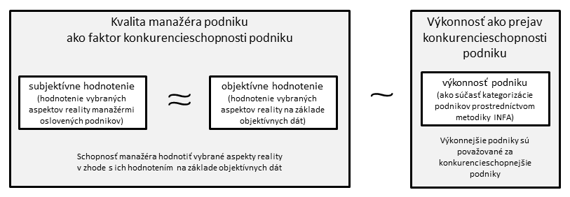
Source: own processing

Picture 1: Example for the picture
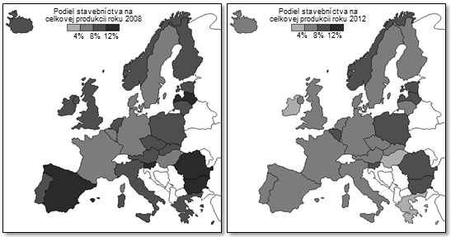
Source: Eurostat, own processing
Conclusion
When quoting please use the APA standard. Links to the sources used in the text of the paper insert directly to the text in the form of author´s name and the year of publication (e.g. Marinič, 2015). Links to the specific pages of the source insert in the form of author´s name, the year of publication, pages (e.g. Marinič, 2015, pp. 10-15). For separation of more sources use semi comas. More sources should be sort alphabetically according to author´s name or in ascending or descending order according to year of publication. In the case of multiple sources of one author in the same year of publication distinguish them by using small letters of alphabet (e.g. Marinič, 2015a; Marinič, 2015b). Complete list of sources used in the paper insert to the references. Do not numbering the list. References insert in order according to author´s name alphabetically, in the case of multiple references of same author order them according to year of publication, and in the case of the multiple references of the same author in the same year of publication order them according to the name of work. Use font volume 12 with left alignment and 0.5 cm indentation with the first line without indentation.
Acknowledgment
Here you can insert acknowledgement to the people and institutions that provide support for the research process leading to writing the paper, if you like.
References
Hendl, J. (2005). Kvalitativní výzkum. Praha: Portál.
Illich, I. (1970). Deschooling society. New York: Harper & Row.
Doyle, W. (1996). Curriculum and pedagogy. In P. W. Jackson (Ed.), Handbook of research on curriculum (s. 486–516). New York: Macmillan.
He, M. F. (2010, v tisku). Exile pedagogy: Teaching in-between. In J. A. Sandlin, B. D. Schultz, & J. Burdick (Eds.), Handbook of public pedagogy: Education and learning beyond schooling (s. 469–482). New York: Routledge.
Schubert, W. H. (1980). Recalibrating educational research: Toward a focus on practice. Educational Researcher, 9(1), 17–24.
Vašťatková, J., & Prášilová, M. (2007). Česká škola = učící se škola. Pedagogická orientace, 17(1), 5–11.
Chvál, M., Michek, S., & Pol, M. (Eds.). (2010). Evaluace ve škole [Monotematické číslo]. Orbis scholae, 4(1).
Johnsen, E. B. (2001). Textbooks in the kaleidoscope. Dostupné z http://www-bib.hive.no/tekster/pedtekst/kaleidoscope/index.html
Jandová, R. (Ed.). (2007). Svět výchovy a vzdělávání v reflexi současného pedagogického výzkumu [CD-ROM]. České Budějovice: JČU.
Najvar, P., & Najvarová, V. (2007). Metodologický postup CPV videostudie anglického jazyka: analýza výuky anglického jazyka na 2. stupni základní školy. In R. Jandová (Ed.), Svět výchovy a vzdělávání v reflexi současného pedagogického výzkumu (s. 1–9). České Budějovice: JČU. [CD-ROM]
Najvar, P., Najvarová, V., & Doležalová, J. (2007). Reading skills of students of faculties of education. Berlin: DGLS. Dostupné z http://www.literacyeurope.org/IDEC/proceedings%20berlin/dolezalova_najvarova_najvar.pdf
Šlégrová, A. (2006). Měření matematické gramotnosti v rámci mezinárodního výzkumu OECD PISA v roce 2003. E-pedagogium, 6(4), 70–77. Dostupné z http://www.upol.cz/fakulty/pdf/e-pedagogium/
Herweg, C. (2008). Zielorientierung im deutschen und schweizerischen Physikunterricht – eine Videostudie (Disertační práce). Kiel: IPN.
Vlčková, K. (2010). Žákovské strategie učení cizímu jazyku ve všeobecném vzdělávání (Habilitační práce). Dostupné z http://is.muni.cz/do/rect/habilitace/1441/Vlckova/habilitace/HABILITACNI_PRACE_2010.pdf
Jacobs, J., Garnier, H., Gallimore, R., Hollingsworth, H., Bogard Givvion, K., Rust, K., … Gonzales, P. (2003). Third international mathematics and science study 1999 video study technical report. Volume 1: Mathematics. Washington: National Center for Education Statistics. Institute of Education Statistics, U. S. Department of Education.
Contact
Full name of the fist author including all degrees
Full name of institution where author works
Full addressee of institution where author works
E-mail for contacting the author
(Note: In case of multiple authors of the paper insert names of the authors in the order as inserted after the heading of the paper containing the abovementioned information about all authors.)

